SUITABLE SUIT

# Introduction

When purchasing a suit, the trouser and jacket are usually sold as a unit and come in numerous sizes. However, some suits may have to be altered to a specific size to fit the individual. This report will present the findings of a mathematical investigation with the aim of using provided data sample from year 10 PMM students to allocate maximum sleeve lengths and maximum corresponding trouser lengths for the following adult sizes: XS, S, M, L, XL. Consequently, recommended the quantity of each suit size a store should store for every 100 suits.

# Considerations

- The sleeve length was the independent variable, and the trouser length was the dependant variable and is thereby interchangeable as it is caused by the external factor, growth.

**- Figuring out the sample space:**

From the 453 students surveyed, it was decided to reduce the sample space to approximately 11.04 % of the population (50 people) to ensure it was an appropriate sample size that would give an accurate representation of the population. To avoid a biased sample that favours one portion of the population, random sampling (a sampling method) was used because the selection of sample size is completely random. Using a random number generator (#Ran) on the fx-CG50 graphics calculator, 50 people were selected. Below in figure 1, the following data is shown.

# Procedure

1. Due to the substantial size of provided data, an appropriate sample of 50 individuals were randomly selected from the 453 Year 10 PMM students.

2. This data of Year 10 PMM students was considered acceptable as it resembles the sizes of adult suits. Technology such as the CASIO fx-CG50 was utilised to generate random numbers hence, representing a more accurate and unbiased representation of data.

3. Appropriate assumptions, observations, and variables necessary to find appropriate maximum sleeve lengths and corresponding trouser lengths for the various sizes were documented

4. The sleeve and trouser measurements for the 50 students were collected and tabulated

5. Assuming that the sleeve length is the independent variable, and the trouser length is the dependent variable, the scatter plot was created using the sample data. Furthermore, the line of best fit was plotted onto the graph to best express the relationship between the sleeve and trouser measurements.

6. An evaluation of the relationship between the variables in the scatterplot was documented

7. The model/equation was found by using the gradient formula ( ) and point slope form

8. The reasonableness of the model was compared with an electronically developed scatter plot using Desmos.

9. For the various sizes (XS, S, M, L, XL) the maximum measurement was allocated using algebra techniques such as , and mathematical reasoning. The 5 different sizes were drawn onto the scatter plot and the quantity of individuals within those different sizes were recorded (39 individuals) and then multiplied by 2.56 to meet the requirements of 100 stock of suits in each size. This is because 11 individuals were not included because they did not fit under the category “If sleeve length increases, trouser length also increase”

10. The results were evaluated, and the reasonableness of solution/investigation was examined. Furthermore, the strengths and weaknesses of the investigation were implemented.

|  |  |
| --- | --- |
| It was assumed that ….. | It was observed that ….. |
| - To determine suit sizes the sleeve and trouser lengths were the only lengths given thus it was not a reliable representation of suit size because other measurements are required in order to create suits. According to Overstock, chest size, height, waist measurements, inseam measurement and sleeve length (Overstock 2021).  - An appropriate sample space of 50 students were chosen from 453 Year 10 PMM students and hence the conclusions of this survey may give a true picture of student’s suit size in general. According to the Australian Bureau of Statistics “The positive square root of the sampling variance, measures the spread of all possible values around the mean (expected value) of an estimator” (Australian Bureau of Statistics, 2021). Thus, 50 people is an appropriate sample as it is a larger amount than the positive square root of 453 (21 people). | - There was 453 Year 10 PMM students surveyed to conduct this investigation and there genders were not identified in the data, therefore it might affect the correlation between the variables because men normally have longer arms and legs than women. This is supported by the website FPFW which states “Men have… longer arms and legs” (Fair Play For Women, 2017).  - Sleeve lengths only included from shoulder to wrist and the trousers only included from the waist to the floor. When measuring the trousers length, shoes were included, thus affecting the accuracy of correlation between sleeve length and trousers length. |

# Results and Discussions

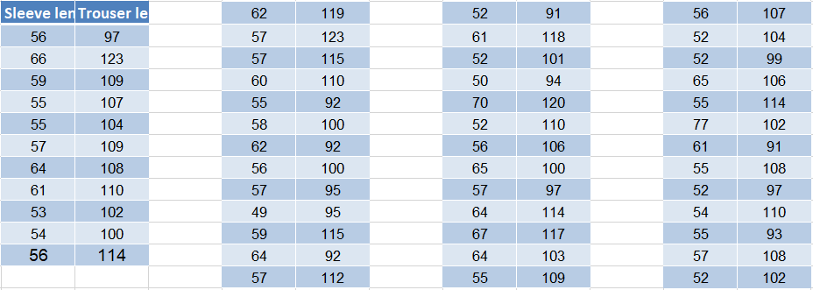***Figure 1:*** *Table that includes the sample size of sleeve lengths and trouser lengths*

Figure 2 shows the relationship between sleeve length and trouser length of year 10 PMM students. On this graph, the sleeve length is represented on the x-axis, and the trouser length is represented on the y-axis. All the 50 people chosen using the random sampling methods were plotted on the scatter plot. Furthermore, the line of best fit was constructed to balance the number of data points above and below the line through observation. It was observed that there was a weak positive correlation between the variables. This is the result of the outliers affecting the accuracy of the line of best fit. The data points (77,102), (66,123) and (57,123) were identified as outliers because they were observed to lie an abnormal distance from the rest of the population. The outliers were also verified using an online outlier calculator. Outliers are bound to happen in an investigation and are unavoidable because every individual has different arm and leg lengths. Therefore, the outliers were included in the graph.

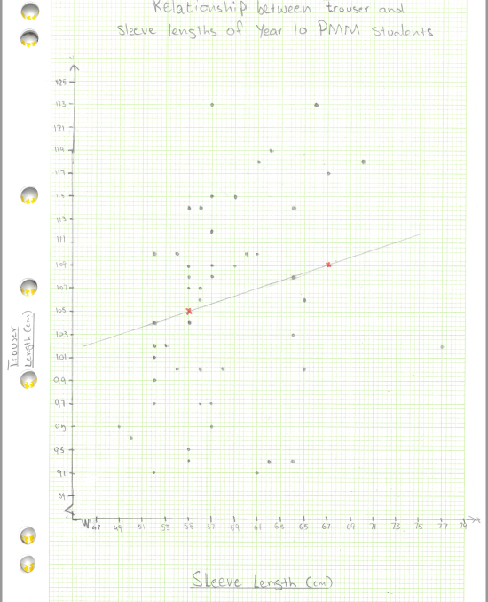***Figure 2:*** *Relationship between sleeve lengths (x-axis) and trouser lengths (y-axis) shown in the scatter plot:*

Domain: 47 79, Range: 89 125

**Finding the model/equation:** The line of best fit was created to express the relationship between the sleeve length (x-axis) and trouser length (y-axis). The line of best fit passes through two data points allowing for equal amount of data points to be above and below the line. To find the equation/model, the gradients of (55,105) and (67,109) was formed by substituting the two points into the gradient formula ( ). Following the identification of the gradient (0.33), Point A and the gradient was inserted into the point slope formula ( to find the equation (). The parameters m (0.33) and c (86.65) were rounded to two decimal places because the model is an approximation for the relationship, thus fractions (exact values) were not used. Through observation of the equation, it can be seen that there is a positive gradient (0.33) thus there will be a positive relationship between the variables and in the sample space of 50 people it was observed that no one had a shorter trouser length than the y intercept (86.65 cm). Therefore, using the model it can be seen that there is a positive relationship between trouser length and sleeve length.

:

The model/equation is

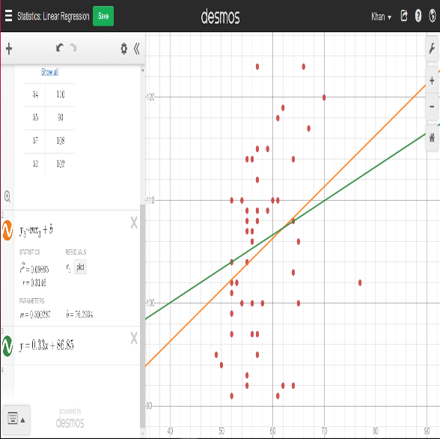***Figure 3:*** *Scatterplot created on Desmos showing the relationship between variables*

***Considering the reasonableness of models:***

The reasonableness of the model was compared with an electronically developed scatter plot using Desmos. They both have a positive gradient, thus indicating that there is a positive relationship between the variables. In the model created on paper, there is a lower gradient than the model on Desmos, but this is compensated for as the model created by hand has a higher y -intercept. There is a difference of 10.54 in the y -intercept and 0.17 difference between the gradient. Even though there is some minor difference between the models, it can be seen on Desmos that both models pass through the same point, however the model created by Desmos has a regression line that is slightly more inclined than the one created on paper. Therefore, it can be considered that the model created on paper has utility (is reasonable and can be used).

**Finding sleeve and trouser lengths for all 5 sizes:**

Difference 6 sizes in each range

[Finding range for sleeve lengths]

|  |  |
| --- | --- |
| Size | Range |
| XS |  |
| S |  |
| M |  |
| L |  |
| XL |  |

=

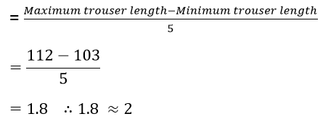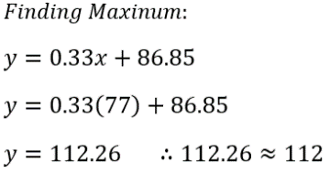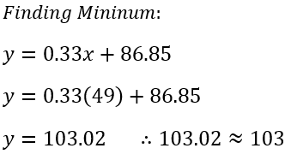[Finding ranges for trouser length]

Difference

|  |  |
| --- | --- |
| Size | Range |
| XS |  |
| S |  |
| M |  |
| L |  |
| XL |  |

|  |  |  |
| --- | --- | --- |
| Size | Finding Maximum sleeve length | Finding Maximum trouser length |
| XS |  |  |
| S |  |  |
| M |  |  |
| L |  |  |
| XL |  |  |

Maximum

Range

**Finding the maximum ranges for sleeve and trouser lengths**

When finding the ranges for sleeve length (independent variable), the range of the sleeve length was calculated and then divided by 5 to find the difference because there are 5 standard sizes that suits come in. The difference (6) was then used to allocate 6 sizes into each range, excluding the XL size, which has 5 sizes because the largest sleeve length recorded from the 50 people is 77, hence the reason the sleeve length of 78 cm wasn’t included. The following maximum sleeve length for each size are; XS (54 cm), S (60 cm), M (66 cm), L (72 cm) and XL (77 cm). Furthermore, the trouser lengths maximum range was found by substituting the lowest and highest sleeve length into the x variable and subtracting them. The range was then divided by 5 to find the difference (2). 2 sizes were then added to each size, resulting in the maximum trouser length of the following sizes to be: XS (104 cm), S (106 cm), M (108 cm), L (110 cm), and XL (112 cm). Even though adding 2 sizes to each range isn’t an accurate way of finding the maximum lengths, it is the most reasonable. This is because if the model was used to find the maximum corresponding trouser lengths, they would end up in decimal form which is unreasonable because sizes are recorded in whole numbers in real life.

**Finding number of suits in range**

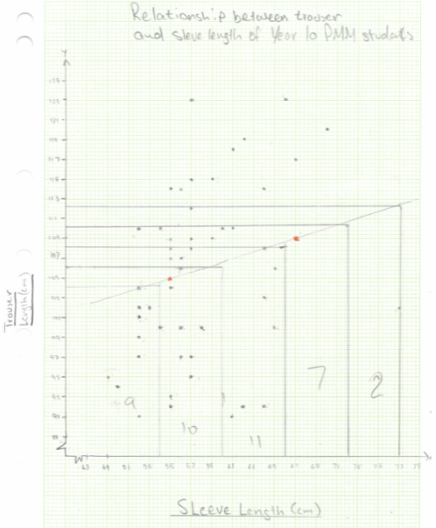The maximum sleeve and trouser lengths were considered and drawn onto the scatterplot to determine the number of suits in each size. It was observed that out of the 50 people, 39 individuals were allocated to a size; however, 11 individuals were not included because they didn’t fall under the category “if sleeve length increases than trouser length also increases”. Instead of multiplying the sample size of 50 by 2 to allow a stock of 100 suits, it was reconsidered to a sample size of 39. Hence, the number of people were counted in each size using figure 4 and multiplied by 2.56 to result in a stock of 100 suit sizes as seen in figure 5

***Figure 5:*** *The number of individuals is allocated in each size in the table*

|  |  |
| --- | --- |
| Sizes | Quantity of students |
| XS |  |
| S |  |
| M |  |
| L |  |
| XL |  |

***Figure 5:*** *The number of individuals are allocated in each size in the table*

***Figure 4:*** *The quantity of individuals are allocated in each size in the scatterplot*

***Figure 4:*** *The quantity of individuals are allocated in each size in the scatterplot*

|  |  |
| --- | --- |
| Sizes | Quantity of students |
| XS |  |
| S |  |
| M |  |
| L |  |
| XL |  |
|  |  |
|  |  |

|  |
| --- |
| Total = XS + S + M + L + XL  = 100  This solution was reasonable because it meets the requirement to determine the quantity for every 100 suits |

# The purpose of this mathematical investigation was to use an appropriate sample size (50 people) to create a model and allocate maximum sleeve and trouser lengths for the five adult suit sizes. Furthermore, a recommendation of the number of suits for each size and every 100 suits were identified. Through appropriate algebra techniques, formulas and mathematical reasoning, the following lengths for each size were developed; XS (54 cm sleeve and 104 cm trouser length), S (60 cm sleeve and 106 cm trouser length), M (66 cm sleeve and 108 cm trouser length), L (72 cm sleeve and 110 cm trouser length), XL (77 cm sleeve and 112 cm trouser length). This solution was reasonable as there was an appropriate sample size and the method of sampling (random sampling) removed a bias toward a portion of the population. In addition, the line of best fit created through observation was similar to the line of regression created electronically on Desmos. However, 11 people were excluded when finding the amount of people in each size because they did not apply under the rule that “if sleeve lengths increase, then trousers length should also increase”. This is also reasonable because, in real-life situations, not everyone will fit into one of the 5 standard sizes. Therefore, they must go to a tailor to lengthen or shorten their sleeve/trouser length to best meet their requirements. During this investigation, there were many strengths and limitations that affected the accuracy of the relationship between the variables.

# **Strengths**

* The number of individuals in each size for every 100 students is an accurate representation of reality because in real life most people fit in between the S and L sizes, thus resulting in the low amount of purchases of XL and XS sizes. XL and XS size suits are then placed on discount to sell quicker.
* Random sampling (a method of sampling) was used because the selection of sample size is completely random and it represents an accurate sample data and avoid a biased sample that favours one portion of the population,
* From the 453 people a large sample size of 50 people (approximately 11.04 %) were selected because it was a greater sample size than the positive root of 453 (21 people) and it gives an accurate representation of the investigation
* The line of best fit developed on Desmos compared to the line of best fit created on paper are both very similar, therefore the model/equation was reasonable to proceed the investigation with.

# **Weaknesses**

* This data utilised the measurements of Year 10 PMM bodies, thus it wouldn’t be acceptable to use these measurements to represent standard adult sizes because the bodies of Year 10 students are still growing and are currently smaller than adults. This is supported by Healthline, “Most people's height won't increase after age 18 to 20” (Yetmen, 2020).
* It was observed that the gender of an individual was not identified in the data; therefore, it might affect the correlation between the variables because men normally have longer arms and legs than women.
* To create a suit, multiple measurements of the body such as the individual’s height, chest size, circumference of neck must be taken. However, in this investigation, it was limited to trouser and sleeve length therefore it is not an accurate representation of the suit sizes.
* When measuring the trousers length, shoes were included, thus affecting the accuracy of correlation between sleeve length and trousers length.

# Conclusion

The aim of this investigation is to find how many suits of each size should be sent in a stock for every 100 suits. The analysis was based on data collected from Year 10 PMM students and a comparison of line of best fit with the least-squared regression line. It was determined through mathematical reasoning that the following number of suits in each size should be sent; XS – 23, S – 26, M – 28, L – 18, XL – 5. This investigation was proven incorrect because it was not an accurate method of obtaining suit sizes. Even though the solution is reasonable, due to the limitations documented, it was observed that this investigation was proved to be unreasonable. Future recommendations such as changing the demographic to Year 11’s and Year 12’s, creating separate sizes for males and females and to have more accurate testing of lengths to improve the accuracy and reasonableness of the solution.

# Appendix

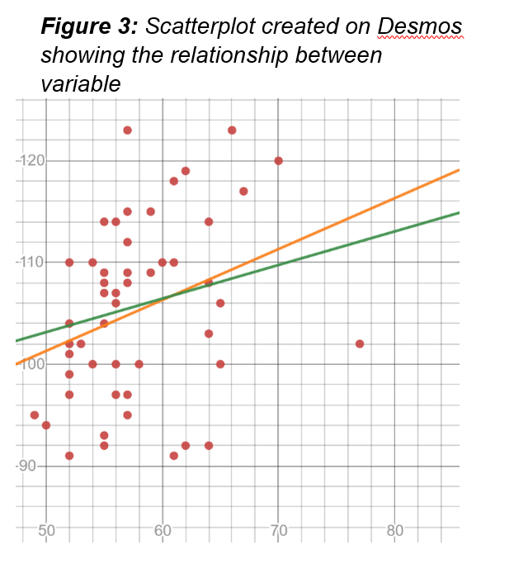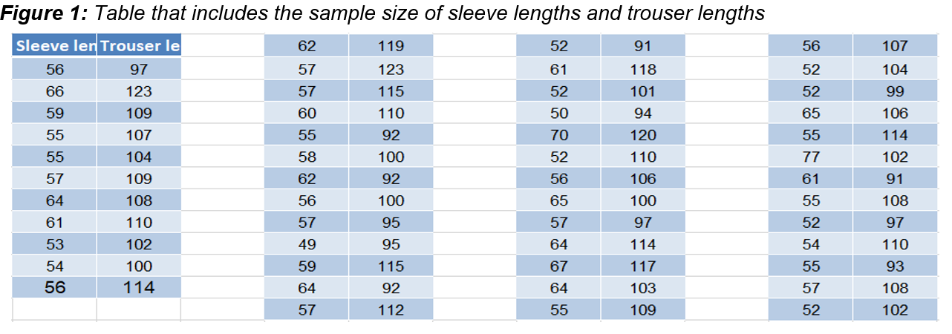

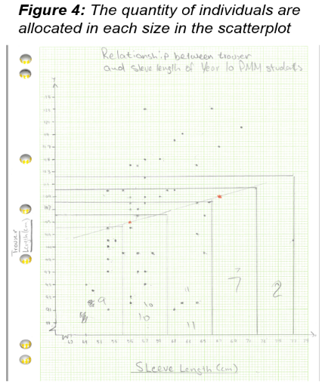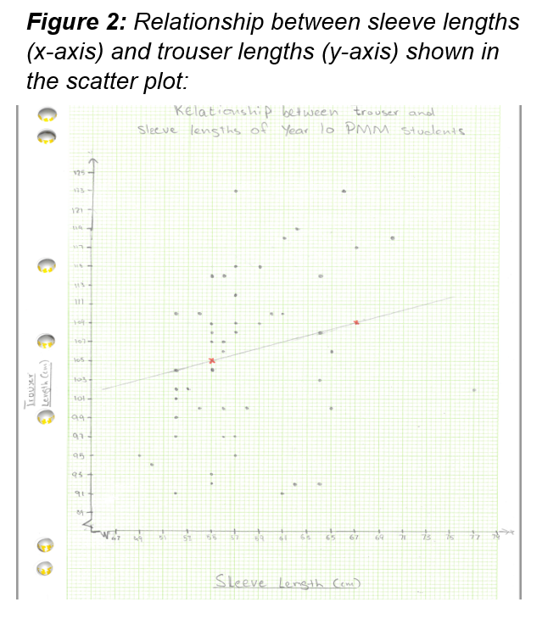

# Bibliography

Australian Bureau of Statistics. (2021). *Methods, Classifications, Concepts & Standards*. Retrieved from Australian Bureau of Statistics: https://www.abs.gov.au/websitedbs/d3310114.nsf/home/Basic+Survey+Design+-+Analysis

Fair Play For Women. (2017). *You are here: Home / Biological sex / Biological sex differences: bones & muscles*. Retrieved from Fair Play For Women: https://fairplayforwomen.com/biological-sex-differences/

Overstock. (2021). *How to Measure Yourself for a Men’s Suit*. Retrieved from Overstock: https://www.overstock.com/guides/how-to-measure-yourself-for-a-mens-suit

Yetmen, D. (2020, June 29). *Do Guys Keep Growing Until Age 25?* Retrieved from Healthline: https://www.healthline.com/health/do-guys-keep-growing-until-age-25#:~:text=Even%20with%20a%20healthy%20diet,20%20(%207%20%2C%208%20).